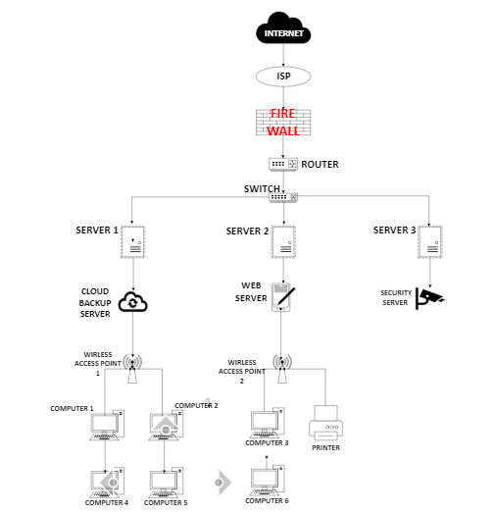

### **Description of Components:**

1. **Internet**: Represents the external connection to the world wide web.
2. **ISP (Openserve)**: The service provider providing internet access.
3. **Firewall** : Protects the network by filtering traffic and preventing unauthorized access.
4. **Router**: Manages traffic between the internal network and the external internet.
5. **Switch** : Connects various devices within the network, allowing them to communicate with each other.
6. **Servers**:
   1. **Server 1 (Database - SQL)**: Hosts the hospital’s database, containing patient records, staff information, etc.
   2. **Server 2 (Application - ERP)**: Runs enterprise resource planning software for administrative and operational management.
   3. **Server 3 (File Server)**: Stores documents and files that staff can access.
   4. **Backup Server (Cloud Backup)**: Provides redundancy for critical data, ensuring data recovery.
   5. **Web Server**: Handles requests for hospital website access and external communication.
   6. **Security Server**: Monitors the network for suspicious activity and manages security protocols.
7. **Wireless Access Points (WAP)**: Extend Wi-Fi coverage throughout the hospital for mobile devices and laptops.
8. **Computers (Workstations)**:
   1. **Admin Staff Computers**: Used for administrative tasks, including scheduling and billing.
   2. **Medical Staff Computers**: Used by doctors and nurses to access patient information and records.
   3. **Nurse Station Computers**: Central stations for nurses to monitor patient data and communicate.
9. **Printers**:
   1. **Printer 1 (Laser)**: Used for printing documents, reports, and patient records.

### **Additional Network Considerations:**

* **Network Security Measures**: Ensure firewalls, antivirus software, and intrusion detection systems are in place to protect sensitive health information.
* **Redundancy and Backup**: Implement redundant systems to ensure uptime and data integrity.
* **Staff Training**: Ensure all staff are trained in cybersecurity protocols and how to use the network efficiently.